Section 5

Records

Records

The Primary Carrier system is utilized for intercompany compensation. This process is dependent upon the exchange of Category 92 originating call records. The Category 92 detail records are summarized into Category 92-99-01 summary records and provided to each ILEC/CLEC on the call path.

The following has been included in this section:

- Record Types Included
- Definition of Category 92 Records
- 92-99-01 Record Layout
- Header and Trailer Requirements

1

Record Types Included

The following record types are included in the Category 92 Intercompany Compensation process:

- 01-01-01 MTS

- 01-01-02 OUTWATS (Non SMDR)

- 01-01-03 OUTWATS (SMDR)

- 01-01-25 Originating 800 (SSP)

- 01-01-31 Local Service

An example of an 01-01-01 MTS and 01-01-31 Local Service record layout are provided on the following pages.

2
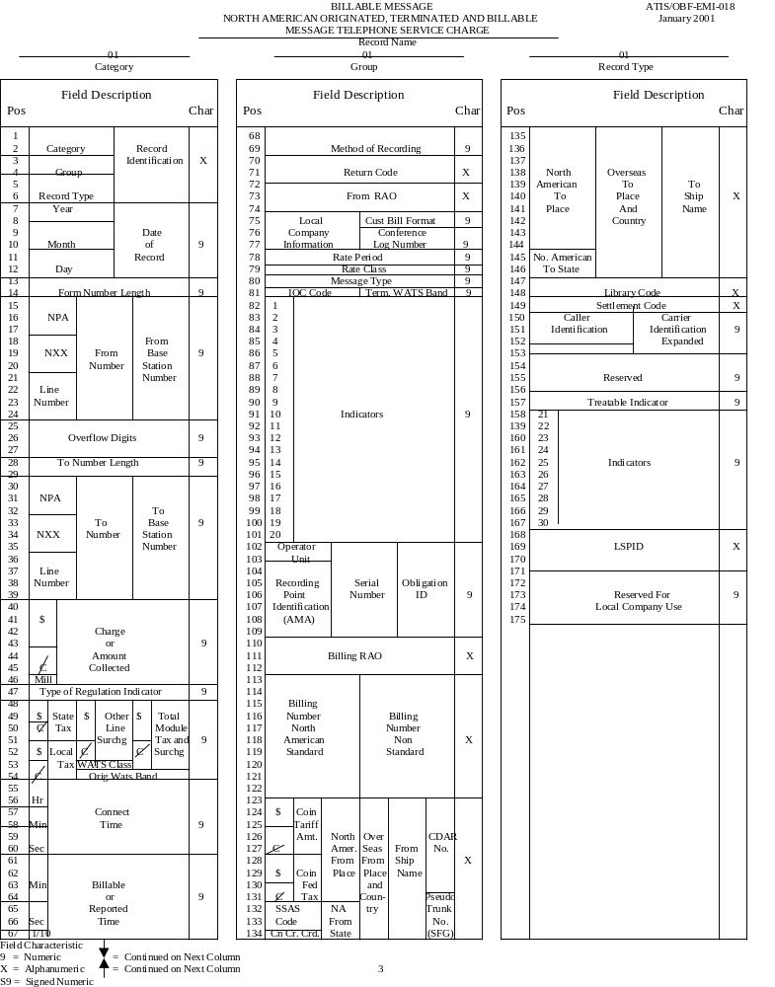
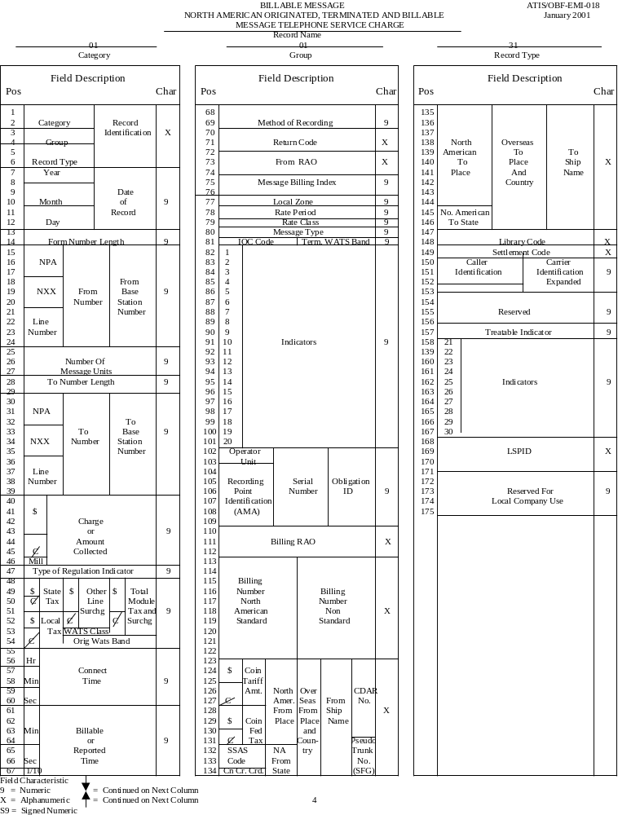

Definition of Category 92 Records

Category 92 detail records are copies of the Category 01 billing records (where XX equals the specific record types) that are included in the Plan. There are two basic types of Category 92 detail records:

- Category 92-01-XX detail records with Indicator 5 set to ‘0’

92-01-XX STL A copy of the Intrastate IntraLATA 01-01-XX EMR message with Indicator 5 = ‘0’. These records are summarized for switched access usage billing.

- Category 92-01-XX detail records with Indicator 5 set to ‘1’

92-01-XX CHR A copy of the Intrastate IntraLATA 01-01-XX EMR message with Indicator 5 = ‘1’. These records are used in the Clearinghouse process.

An example of the 92-01-01 record layout is provided on the following page.

5

Intrastate/Intralata Originating Message Telephone Service
92-01-01
 | Pos |  | Field Description |  |  |  | Char |  | 75 | Local |  |  |  | 150 | Carrier | Carrier
 | 1 |  | Category |  |  |  |  |  | 76 | Company |  | 9 |  | 151 | Identification | Identification
 | 2 |  |  |  |  |  |  |  | 77 | Information |  |  |  | 152 |  | Expanded | 9
 | 3 |  | Group |  | Record |  | 9 |  | 78 | Rate Period |  | 9 |  | 153
 | 4 |  |  |  | Identificaiton |  |  |  | 79 | Rate Class |  | 9 |  | 154
 | 5 |  | Record Type |  |  |  |  |  | 80 | Message Type |  | 9 |  | 155 | Reserved
 | 6 |  |  |  |  |  |  |  | 81 | Term WATS Band |  | 9 |  | 156 |  |  | 9
 | 7 |  | Year |  |  |  |  |  | 82 | 1 |  |  |  | 157
 | 8 |  |  |  |  |  |  |  | 83 | 2 |  |  |  | 158 | 21
 | 9 |  | Month |  | Date |  | 9 |  | 84 | 3 |  |  |  | 159 | 22
 | 10 |  |  |  | Of |  |  |  | 85 | 4 7=UNE |  |  |  | 160 | 23
 | 11 |  | Day |  | Record |  |  |  | 86 | 5 1=CLH |  |  |  | 161 | 24
 | 12 |  |  |  |  |  |  |  | 87 | 6 |  |  |  | 162 | 25 Indicators |  | 9
 | 13 |  | From Number |  |  |  |  |  | 88 | 7 |  |  |  | 163 | 26
 | 14 |  | Length |  |  |  | 9 |  | 89 | 8 |  |  |  | 164 | 27
 | 15 |  |  |  |  |  |  |  | 90 | 9 |  |  |  | 165 | 28
 | 16 |  | NPA |  |  |  |  |  | 91 | 10 Indicators |  | 9 |  | 166 | 29
 | 17 |  |  |  |  |  |  |  | 92 | 11 |  |  |  | 167 | 30
 | 18 |  |  |  |  |  |  |  | 93 | 12 |  |  |  | 168
 | 19 |  | NXX |  | From |  |  |  | 94 | 13 |  |  |  | 169 | Originating OCN
 | 20 |  |  |  | Number |  | 9 |  | 95 | 14 |  |  |  | 170 | of UNE Customer |  | 9
 | 21 |  |  |  |  |  |  |  | 96 | 15 |  |  |  | 171
 | 22 |  | Line Number |  |  |  |  |  | 97 | 16 |  |  |  | 172 | Indicator on UNE |  | 9
 | 23 |  |  |  |  |  |  |  | 98 | 17 |  |  |  |  | 1= orig. 2= term.
 | 24 |  |  |  |  |  |  |  | 99 | 18 |  |  |  | 173 | Transport ID |  | 9
 | 25 |  |  |  |  |  |  |  | 100 | 19 |  |  |  | 174 | Reserved |  | X
 | 26 |  | Blank |  |  |  |  |  | 101 | 20 |  |  |  | 175 | 1= swapped dialed
 | 27 |  |  |  |  |  |  |  | 102 | Operator |  |  |  |  | with LRN npanxx line |  | 9
 | 28 |  |  |  |  |  |  |  | 103 | Unit |  |  |  | 176
 | 29 |  | To Number Length |  |  |  | 9 |  | 104 |  | Serial |  |  | 177 | NPA
 | 30 |  |  |  |  |  |  |  | 105 | Recording | Number | 9 |  | 178
 | 31 |  | NPA |  |  |  |  |  | 106 | Point | & |  |  | 179
 | 32 |  |  |  |  |  |  |  | 107 | Indent. | Obligation |  |  | 180 | NXX | Originating | 9
 | 33 |  |  |  |  |  |  |  | 108 |  | ID |  |  | 181 |  | LRN
 | 34 |  | NXX |  | To |  |  |  | 109 |  |  |  |  | 182
 | 35 |  |  |  | Number |  | 9 |  | 110 |  |  |  |  | 183 | Line
 | 36 |  |  |  |  |  |  |  | 111 | Billing RAO |  | 9 |  | 184 | Number
 | 37 |  | Line Number |  |  |  |  |  | 112 |  |  |  |  | 185
 | 38 |  |  |  |  |  |  |  | 113 |  |  |  |  | 186
 | 39 |  |  |  |  |  |  |  | 114 |  |  |  |  | 187 | NPA
 | 40 |  |  |  |  |  |  |  | 115 |  |  |  |  | 188
 | 41 |  |  |  |  |  |  |  | 116 | Billing | Billing |  |  | 189
 | 42 |  | Dollar |  | Charge or |  |  |  | 117 | Number | Number |  |  | 190 | NXX | Terminating | 9
 | 43 |  |  |  | amount |  |  |  | 118 | North | Non- | X |  | 191 |  | LRN
 | 44 |  |  |  | Collected |  | 9 |  | 119 | American | Standard |  |  | 192
 | 45 |  | Cent |  |  |  |  |  | 120 | Standard |  |  |  | 193 | Line
 | 46 |  | Mill |  |  |  |  |  | 121 |  |  |  |  | 194 | Number
 | 47 |  | Regulator Indicator |  |  |  | 9 |  | 122 |  |  |  |  | 195
 | 48 |  |  |  |  |  |  |  | 123 |  |  |  |  | 196
 | 49 |  | Dollar |  | State |  |  |  | 124 |  |  |  |  | 197 | NPA
 | 50 |  |  |  | Tax |  |  |  | 125 |  |  |  |  | 198
 | 51 |  | Cent |  |  |  | 9 |  | 126 |  |  |  |  | 199
 | 52 |  | Dollar |  |  |  |  |  | 127 | North America |  |  |  | 200 | NXX | Billing
 | 53 |  |  |  | Local Tax |  |  |  | 128 | from Place |  | X |  | 201 |  | LRN | 9
 | 54 |  | Cent |  |  |  |  |  | 129 |  |  |  |  | 202
 | 55 |  |  |  |  |  |  |  | 130 |  |  |  |  | 203 | Line
 | 56 |  | Hour |  |  |  |  |  | 131 |  |  |  |  | 204 | Number
 | 57 |  |  |  | Connect |  | 9 |  | 132 |  |  |  |  | 205
 | 58 |  | Minute |  | Time |  |  |  | 133 | From |  |  |  | 206 | Reserved |  | X
 | 59 |  |  |  |  |  |  |  | 134 | State |  |  |  | 207 | Originating
 | 60 |  | Second |  |  |  |  |  | 135 |  |  |  |  | 208 | Recording Only.
 | 61 |  |  |  |  |  |  |  | 136 |  |  |  |  | 209 | Terminating |  | 9
 | 62 |  | Minute |  |  |  |  |  | 137 |  |  |  |  | 210 | UNE Company
 | 63 |  |  |  | Billable |  |  |  | 138
 | 64 |  |  |  | or |  | 9 |  | 139 | North America
 | 65 |  |  |  | Reported |  |  |  | 140 | to Place
 | 66 |  | Second |  | Time |  |  |  | 141 |  |  | X
 | 67 |  | Tenth |  |  |  |  |  | 142
 | 68 |  | Method of Recording |  |  |  | 9 |  | 143
 | 69 |  |  |  |  |  |  |  | 144
 | 70 |  | Return Code |  |  |  | X |  | 145 | North America to
 | 71 |  |  |  |  |  |  |  | 146 | State
 | 72 |  | From RAO |  |  |  | 9 |  | 147 | Library
 | 73 |  |  |  |  |  |  |  | 148 | Code |  | X
 | 74 |  |  |  |  |  |  |  | 149 | Settlement Code |  | X
 | Field Characteristic: 9 = Numeric X = Alphanumeric

8/1/00

6
92-01-XX Detail Record Creation

The 92-01-XX detail is a copy of the 01-01-XX.

FROM | TO | LENGTH | TYPE | VALUE | DESCRIPTION
1 | 6 | 6 | N | 920101 = MTS  920102 = OUTWATS  920103 = OUTWATS  920125 = Orig. 800  920131 = Local | Message ID
7 | 12 | 6 | N | YYMMDD | Message Date
13 | 14 | 2 | N | 10 | Number of Digits in the “From Number”
15 | 24 | 10 | N | NPANXXLLLL | “From” NPA/NXX and line number
25 | 27 | 3 | N | 0 | Overflow Digits
28 | 29 | 2 | N | 10 | Number of Digits in the “To Number”
30 | 39 | 10 | N | NPANXXLLLL | “To” NPA/NXX and line number
40 | 46 | 7 | N | 0 | Charge or Amount Collected
47 | 47 | 1 | N | 0 | Type of Regulation Indicator
48 | 54 | 7 | N | 0 | Taxes
55 | 60 | 6 | N | HHMMSS | Connect Time or Time of Day the call began
61 | 67 | 7 | N | MMMMSST | Billable Time
68 | 69 | 2 | N | See EMI, 4-90 – 4-92 | Method of Recording
70 | 71 | 2 | N | 0 | Return Code
72 | 74 | 3 | X |  | From RAO

7
92-01-XX Detail Record Creation (Cont’d.)

The 92-01-XX detail is a copy of the 01-01-XX.

75 | 77 | 3 | N | 0 | Local Company Information
78 | 78 | 1 | N | 0-6 | Rate period based on time and/or day of week (See EMI, 4-116)
79 | 79 | 1 | N | 1-6 | Rate class based on whether the message was person or station and customer-dialed or OPH (See 4-116)
80 | 80 | 1 | N | 1=Sent Paid  2=Third Number  3=Calling Card  4=Collect  5=Special Collect  6=Coin Paid | Message type identifies the billing arrangement
81 | 81 | 1 | N | 0 | IOC Code
82 | 101 | 20 | N | See EMI, 4-52, 4-58 | Commonly used Indicators are:  Indicator 4 = 7 for UNE  Indicator 5 = 0 for STL  Indicator 5 = 1 for CHR
102 | 103 | 2 | N | 0-9 | Operator Unit
104 | 109 | 6 | N | 0-9 | Recording Point Identifier
110 | 112 | 3 | X |  | Billing RAO
113 | 122 | 10 | N | NPANXXLLLL | Billing NPA/NXX and line number
123 | 134 | 12 | X |  | Standard abbreviation of the location and state from which the message originated
 |  |  |  | 8
92-01-XX Detail Record Creation (Cont’d.)

The 92-01-XX detail is a copy of the 01-01-XX.

135 | 146 | 12 | X |  | Standard abbreviation for the called location and state
147 | 148 | 2 | X |  | Library code used to identify the source of messages recorded
149 | 149 | 1 | X | 6=Local  8=Intrastate – U.S./U.S. | Settlement Code for the classification of messages
150 | 153 | 4 | N | 0 | CIC Code
154 | 156 | 3 | N | 0 | Reserved
157 | 157 | 1 | N | 0 | Treatable indicator
158 | 167 | 10 |  | See EMI, 4-52 – 4-58 | Indicators
168 | 171 | 4 | N |  | Originating OCN of UNE Customer
172 | 172 | 1 | N | 1=Originating UNE  2=Terminating UNE | Orig./Term. Indicator on UNE records only
173 | 173 | 1 | N | 0 | Transport ID – For local company use
174 | 174 | 1 |  |  | Reserved
175 | 175 | 1 | N | 1=LRN Substitution  0=No LRN Substitution | LRN Substitution Performed
176 | 185 | 10 | N | NPANXXLLLL | Originating LRN
186 | 195 | 10 | N | NPANXXLLLL | Terminating LRN
196 | 205 | 10 | N | NPANXXLLLL | Billing LRN
206 | 206 | 1 | N | 0 | Reserved
207 | 210 | 4 | N |  | Originating Recording Identifying Terminating UNE Company

9

Definition of Category 92 Records (cont’d.)

Category 92-99-01 Summary records are used for intercompany settlements. These records are summaries of the Category 92-01-XX detail records and utilize a ‘traffic type’ to identify the type of usage. These records are exchanged monthly.

92-99-01 A summary of the 92-01-XX detail message summarized by date, traffic type, originating aggregate NPA/NXX and terminating NPA/NXX. 92-01-XX CHR messages are not included in this summary record.

An example of the 92-99-01 summary record is provided on the following page.

10
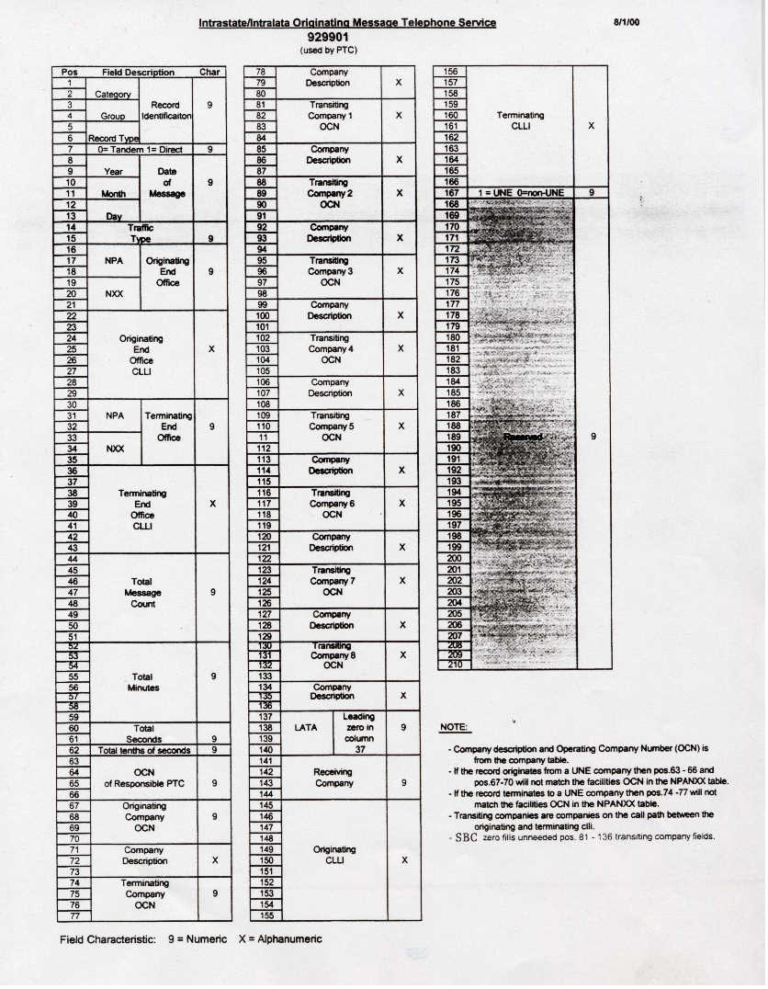

92-99-01 Summary Record Creation

FROM | TO | LENGTH | TYPE | VALUE | SOURCE | DESCRIPTION
1 | 6 | 6 | N | 929901 |  | Message ID
7 | 7 | 1 | N | 0  1 |  | Tandem  Direct
8 | 13 | 6 | N | YYMMDD | 92-01-XX Position 7-12 | Message Date
14 | 15 | 2 | N |  |  | Traffic Type
 |  |  |  | 01 |  | 01=MTS
 |  |  |  | 02 |  | 02=WATS
 |  |  |  | 03 |  | 03=ORIG. 800 DAL
 |  |  |  | 04 |  | 04=ORIG. 800 CML
 |  |  |  | 05 |  | 05=OPH
 |  |  |  | 10 |  | 10=LOCAL
 |  |  |  | 11 |  | 11=LOCAL EAS
 |  |  |  | 12 |  | 12=Local Plus (AT&T orig.)
 |  |  |  | 13 |  | 13=Local Plus (non-AT&T orig.)
 |  |  |  | 14 |  | 14=IntraLATA Wholesale Svc. (IWS)
 |  |  |  | 15 |  | 15=Local Minutes Plus
16 | 21 | 6 | N | 0-9 | Table 80 | Aggregate originating NPA/NXX (The six digit NPA/NXX of the originating end office)
22 | 29 | 8 | AN |  | Table 80 | Originating CLLI code (The first 8 characters of the originating CLLI code associated with the originating NPA/NXX in positions 16-21 above)
30 | 35 | 6 | N | 0-9 | Table 80 | Aggregate terminating NPA/NXX (The six digit NPA/NXX of the terminating end office)
36 | 43 | 8 | AN |  | Table 80 | Terminating CLLI code (The first 8 characters of the terminating CLLI code associated with the terminating NPA/NXX in positions 30-35 above)

AN = AlphaNumeric N = Numeric

12

92-99-01 Summary Record Creation (Cont’d.)

44 | 51 | 8 | N | ≠ Blank | Calculated | Total Message Count
52 | 59 | 8 | N | ≠ Blank | Sum of  92-01-XX Position  61-64 | Total Minutes
60 | 61 | 2 | N | ≠ Blank | Sum of  92-01-XX Position  65-66 | Total Seconds
62 | 62 | 1 | N | ≠ Blank | Sum of  92-01-XX Position 67 | Total Tenths of Seconds
63 | 66 | 4 | N | 0-9 | Table 80 | NECA Code of PTC (PTC creating 92-99-01)
67 | 70 | 4 | N | 0-9 | Table 80 | Originating LEC NECA code (The four digit NECA code associated with the LECs aggregate originating NPA/NXX in positions 16-21 above)
71 | 73 | 3 | AN | SWB  GTE  CEN  SC  LSP  LUF  UTC  FID  CON  CSM  SGL  AP  ALT  UNE | Table 30 | LEC Description Table  Code  SWB-AT&T  GTE-GTE  CEN-Centel (TX)  SC-Secondary Carrier (MO, KS)  LSP-Local Service Provider  LUF-Lufkin Conroe (TX)  UTC-United (TX, MO, KS)  FID-Fidelity (MO)  CON-Contel (TX, MO, AR, KS)  CSM-Century-San Marcos (TX)  SGL-Sugarland (TX)  AP-Access Provider (OK)  ALT-Alltel (AR)  UNE-Unbundled Network Element

13
92-99-01 Summary Record Creation (Cont’d.)

74 | 77 | 4 | N | 0-9 | Table 80 | Terminating LEC NECA code (The four digit NECA code associated with the LECs aggregate terminating NPA/NXX in positions 30-35 above)
78 | 80 | 3 | AN |  | Table 30 | LEC Description (See positions 71-73 above)
81 | 84 | 4 | N | 0-9 | Tables 50 and 60 | Transiting LEC #1 (The four digit NECA code of the transiting LEC in the path of the call located between the originating and terminating LEC)
85 | 87 | 3 | AN |  | Table 30 | LEC Description (See positions 71-73 above)
88 | 91 | 4 | N | 0-9 | Tables 50 and 60 | Transiting LEC #2 (The four digit NECA code of the transiting LEC in the path of the call located between the originating and terminating LEC)
92 | 94 | 3 | AN |  | Table 30 | LEC Description (See positions 71-73 above)
95 | 98 | 4 | N | 0-9 | Tables 50 and 60 | Transiting LEC #3 (The four digit NECA code of the transiting LEC in the path of the call located between the originating and terminating LEC)
99 | 101 | 3 | AN |  | Table 30 | LEC Description (See positions 71-73 above)
102 | 105 | 4 | N | 0-9 | Tables 50 and 60 | Transiting LEC #4 (The four digit NECA code of the transiting LEC in the path of the call located between the originating and terminating LEC)
106 | 108 | 3 | AN |  | Table 30 | LEC Description (See positions 71-73 above)

14

92-99-01 Summary Record Creation (Cont’d.)

109 | 112 | 4 | N | 0-9 | Tables 50 and 60 | Transiting LEC #5 (The four digit NECA code of the transiting LEC in the path of the call located between the originating and terminating LEC)
113 | 115 | 3 | AN |  | Table 30 | LEC Description (See positions 71-73 above)
116 | 119 | 4 | N | 0-9 | Tables 50 and 60 | Transiting LEC #6 (The four digit NECA code of the transiting LEC in the path of the call located between the originating and terminating LEC)
120 | 122 | 3 | AN |  | Table 30 | LEC Description (See positions 71-73 above)
123 | 126 | 4 | N | 0-9 | Tables 50 and 60 | Transiting LEC #7 (The four digit NECA code of the transiting LEC in the path of the call located between the originating and terminating LEC)
127 | 129 | 3 | AN |  | Table 30 | LEC Description (See positions 71-73 above)
130 | 133 | 4 | N | 0-9 | Tables 50 and 60 | Transiting LEC #8 (The four digit NECA code of the transiting LEC in the path of the call located between the originating and terminating LEC)
134 | 136 | 3 | AN |  | Table 30 | LEC Description (See positions 71-73 above)
137 | 140 | 4 | N | 0-9 | Table 80 | LATA Code
141 | 144 | 4 | N | 0-9 | Table 80 | Receiving LEC  Transiting LEC
145 | 155 | 11 | AN | 0-9 | Table 60 | Originating CLLI Code

15

92-99-01 Summary Record Creation (Cont’d.)

156 | 166 | 11 | AN | 0-9 | Table 60 | Terminating CLLI Code
167 | 167 | 1 | N | 1 |  | UNE
 |  |  |  | 0 |  | Not UNE
168 | 210 | 43 | N | 0 |  | Reserved

16

Traffic Type

Instructions for Creating 92-99-01 Records

IF: THEN:

EMR METHOD OF INDICATOR CREATE
RECORD RECORDING AND 5 26 TRAFFIC TYPE
| |
MTS | |
01-01-01 01, 02, 03, 04* 0 | | 1
| |
OUTWATS | |
01-01-02 | |
01-01-03 0 | | 2
| |
ORIG 800 DAL | |
01-01-25 0 | 9 | 3
| |
ORIG 800 CML | |
01-01-25 0 | 8 | 4
| |
OPH | |
01-01-01 04*, 11, 12, 21, | |
22, 31, 32, 33, 41, 43 0 | | 5
| |
LOCAL | |
01-01-31 01, 02, 03, 04** 0 | | 10
| |
LOCAL EAS | |
01-01-31 01, 02, 03, 04** 0 | | 11
| |
AT&T Local Plus | |
01-01-01 01, 02, 03, 04** 0 | | 12
| |
Oklahoma AWCS | |
01-01-01 01, 02, 03, 04** 0 | | 13
| |
AT&T IWS | |
01-01-01 01, 02, 03, 04** 0 | | 14
| |
E.A.C. | |
01-01-01 01, 02, 03, 04** 0 | | 15

*MTS ( Message Type 1, 6) & OPH (Message Type 2, 3, 4, 5)
**MTS (Message Type 1, 6)

17

Header and Trailer Requirements

Headers and Trailers are required for data processing. The appropriate Headers and Trailers are based on a company’s RAO status.

There are two types of standard Bell – Non-Bell Exchange Carrier Pack Header and Trailer record formats used for data transmission:

Format

- Full RAO Companies use 20-20-XX

- Non-Full RAO Companies use 20-21-XX

Category 92 records cannot be transmitted over CMDS and require a separate transmission from other types of records.

For Category 92 records, we substitute a ‘90’ (Full RAO Companies) or ‘91’ (Non-Full RAO Companies) for the record group in the standard EMR Bell – Non-Bell Exchange Carrier Pack Header and Trailer record formats shown above:

Category 92 Records Header Trailer

- Full RAO Companies use 20-90-01 20-90-02

- Non-Full RAO Companies use 20-91-01 20-91-02

18

Category 92 Record Header and Trailer Invoice Numbers

- Must be sequential.

- An invoice number must be accepted before the next sequential invoice number will be accepted.

- The invoice number on the header must match the master number in the program.

- The header and trailer invoice numbers must match.

- Must begin with ‘01’.

19

Header and Trailer Records

Full Status RAO Companies

20-90-01 A copy of the Standard EMR 20-20-01 CMDS Pack Header Record. This record is used by full status RAO companies for the Category 92 records with the group value changed from ‘20’ to ‘90’.

20-90-02 A copy of the Standard EMR 20-20-02 CMDS Pack Trailer Record. This record is used by full status RAO Companies for the Category 92 records with the group value changed from ‘20’ to ‘90’.

An example of the 20-90-01 record layout is provided on the following page.

An example of the 20-90-02 record layout is provided on the following page.

20

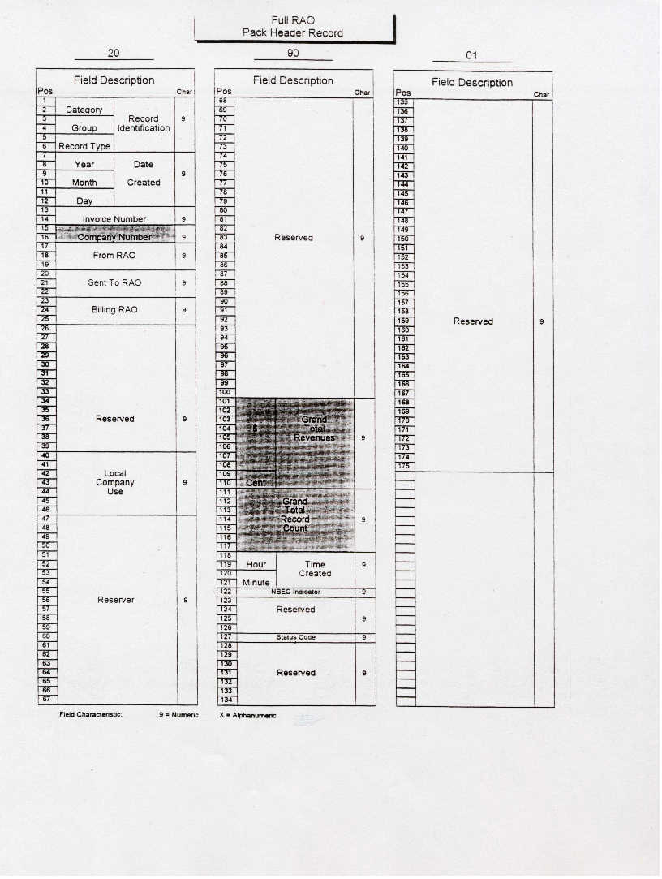

21
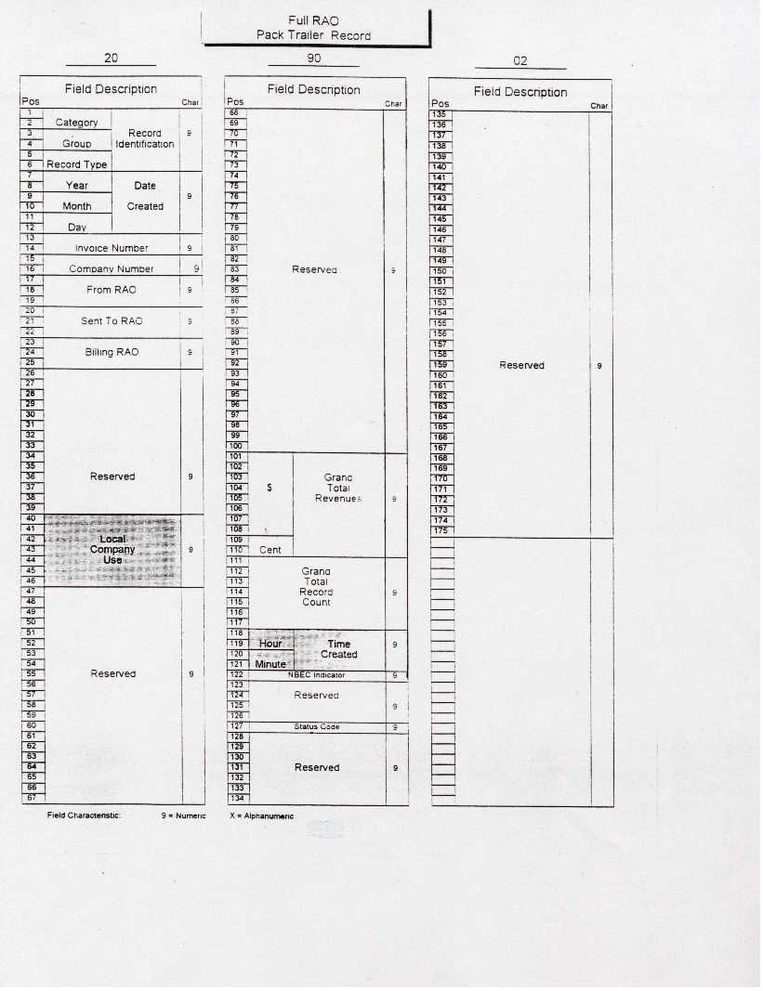

22

Header and Trailer Records

Non-Full Status RAO Companies

20-91-01 A copy of the Standard EMR 20-21-01 Bell – Non-Bell Exchange Carrier message file Pack Header record. This record is used by non-full status RAO companies for the Category 92 records with the group value changed from ‘21’ to ‘91’.

20-91-02 A copy of the Standard EMR 20-21-02 Bell – Non-Bell Exchange Carrier message file Pack Trailer Record. This record is used by non-full status RAO companies for the Category 92 records with the group value changed from ‘21’ to ‘91’.

A copy of the 20-91-01 record layout is provided on the following page.

A copy of the 20-91-02 record layout is provided on the following page.

23
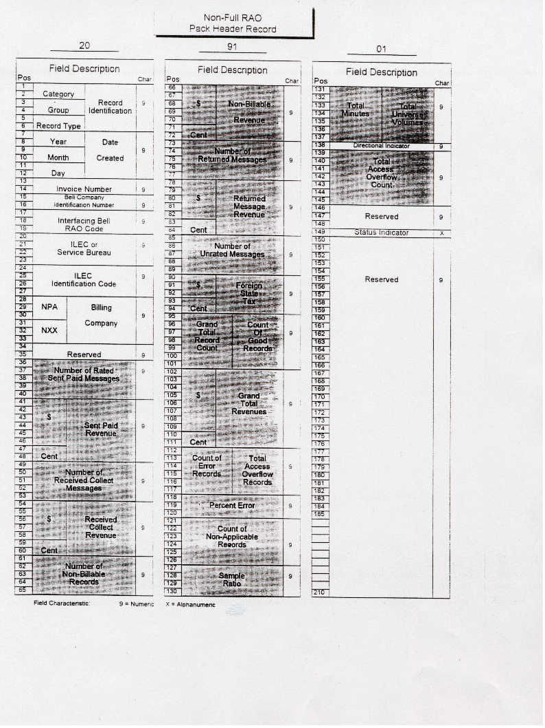

24

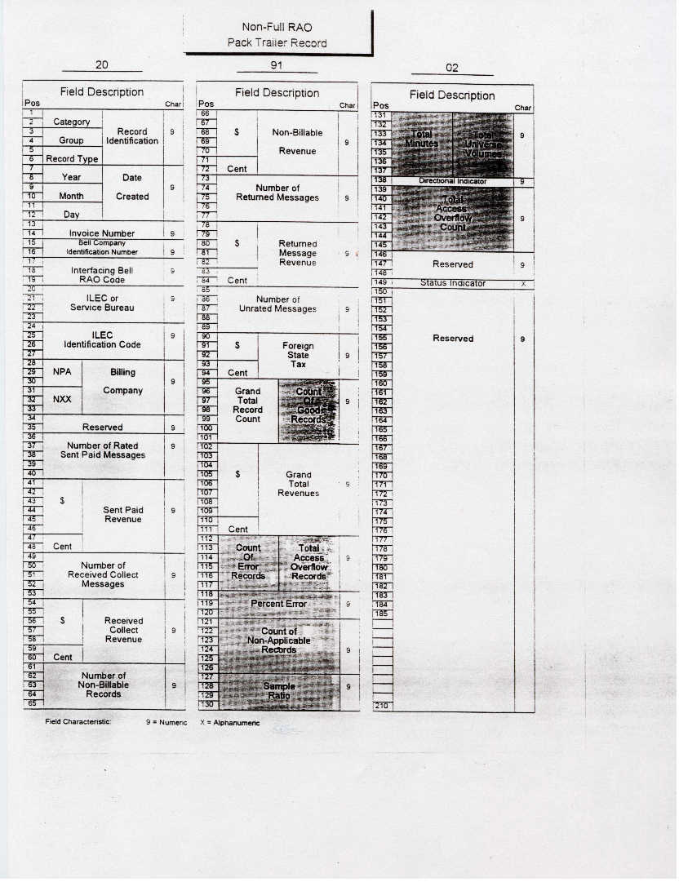

25

